# Lab Number: 03 Date: 2025/07/01

# Title: OS Installation & Practice on Basic Networking Commands

## THEORY:

**Linux:**

Linux is a family of open-source operating systems, based on the Linux kernel, first released in 1991 by Linus Torvalds. It’s known for its flexibility, security, and wide range of applications, from smartphones and servers to supercomputers and embedded systems. While often referred to as an OS, Linux is technically a kernel, which is the core of an operating system. Linux distributions, like Ubuntu or Fedora, bundle the kernel with other software to create a complete OS.



Fig.: Linux OS and its Evolution and Future

**Virtual Box:**

VirtualBox is free and open-source virtualization software that allows users to run multiple operating systems on a single physical machine. It enables the creation and management of virtual machines (VMs), each capable of hosting a different OS alongside the host system. This capability is useful for testing software, developing applications on various platforms, and creating isolated environments for experimentation. Essentially, it provides the functionality of multiple computers within a single computer.

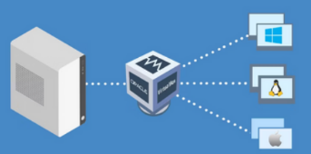

Fig.: Virtual Box

**VMware:**

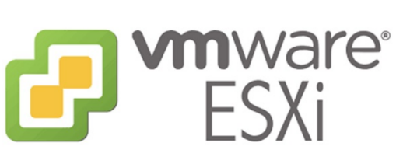VMware is a leading provider of virtualization and cloud computing software and services. It enables the creation of virtual machines, which are software-based versions of physical computers, allowing users to run multiple operating systems and applications on a single physical machine. This virtualization technology offers benefits like increased efficiency, improved resource utilization, and simplified data center management. VMware’s core product, vSphere, is a suite of virtualization tools that includes the ESXi hypervisor, which manages the allocation of hardware resources to virtual machines.

Fig.: VMware

**Installing Virtual Box:**

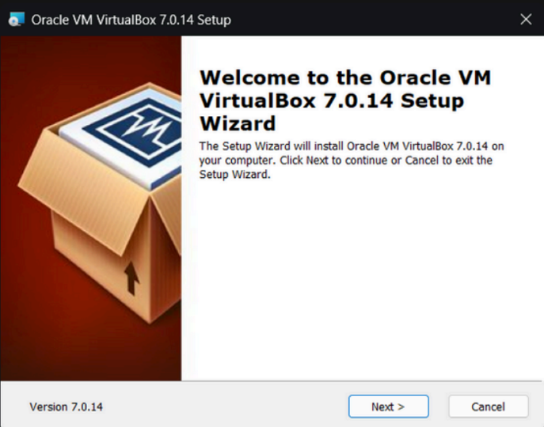Installing a virtual machine (VM) enables running multiple operating systems on one physical machine parallelly, useful for testing, development in isolated environments, and efficient resource use. VMs also support backups, disaster recovery, and enhanced security compared to traditional setups.

Here, click on **Next** and go to next phase.

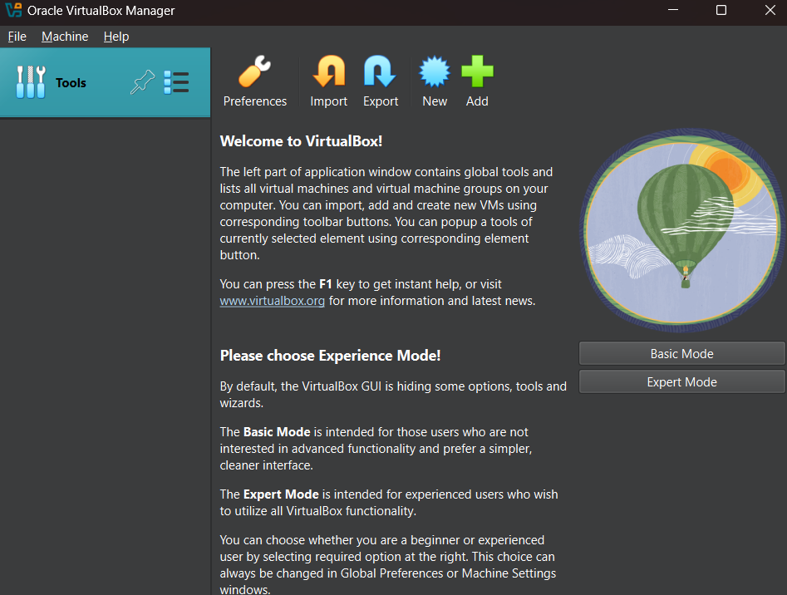Once Virtual Box is installed then we can create, add or import new VMs using toolbar buttons

**Installing Linux (Ubuntu) Desktop OS:**

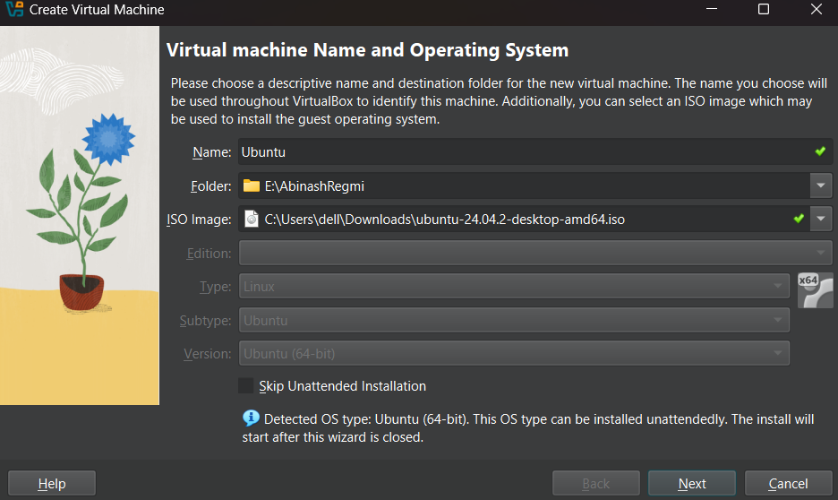**Step 1:** Click New on Virtual Machine toolbar and add details about the new VM and required OS.

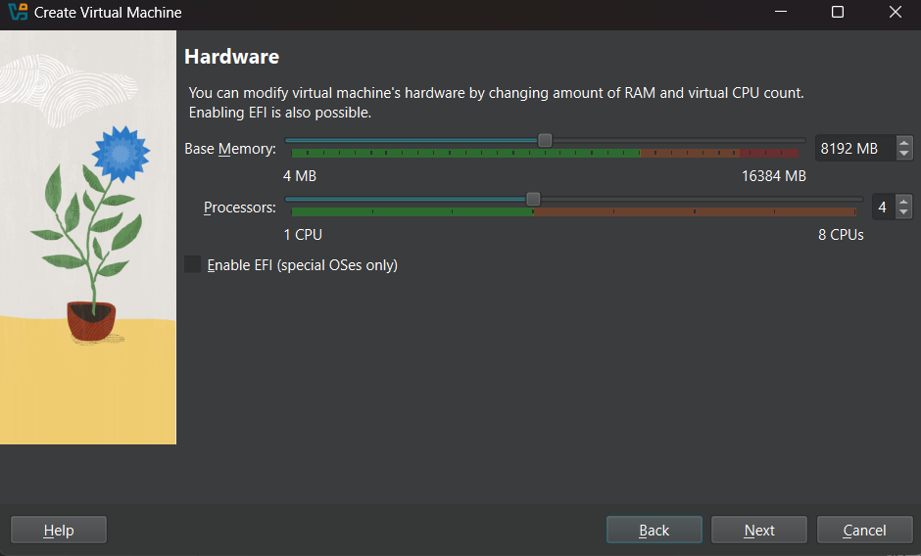**Step 2:** Select the Base Memory and Processors to be allocated to the Virtual Machine as per your need.

**Step 3:** Select the size of memory you want for Virtual Hard Disk.

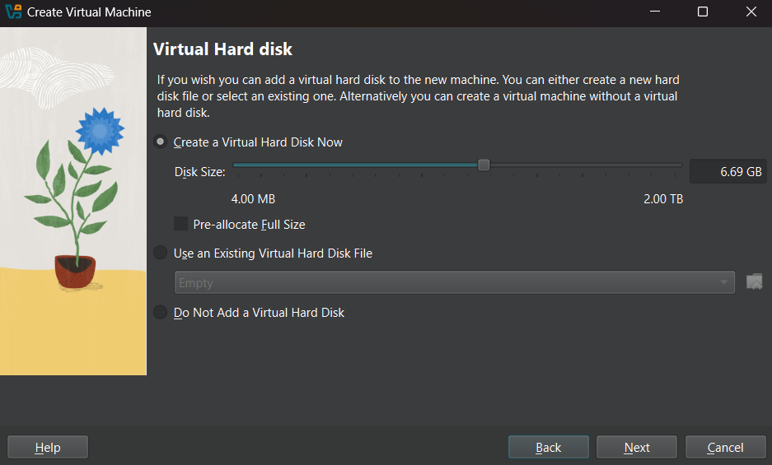

**Step 4:**  This is the interface for the newly created Virtual Machine for Ubuntu Desktop OS. Select Server and click on Start to run the Virtual Machine

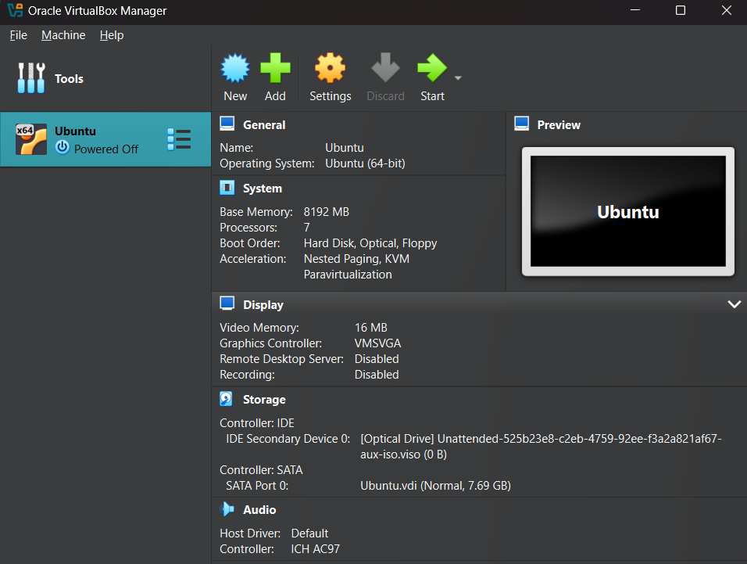

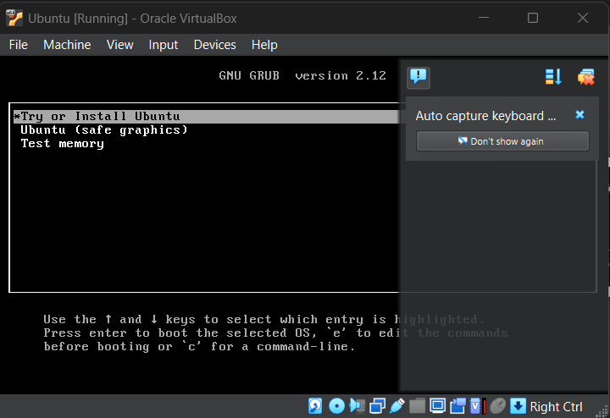**Step 5:** Press Enter to install Ubuntu Server.

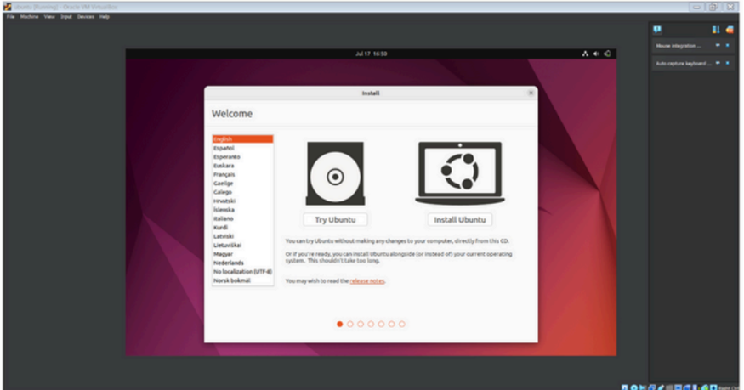**Step 6:** Select the preferred language and click on Install Ubuntu.

**Step 7:** Select the preferred keyboard layout and its variant, click on Continue once finished.

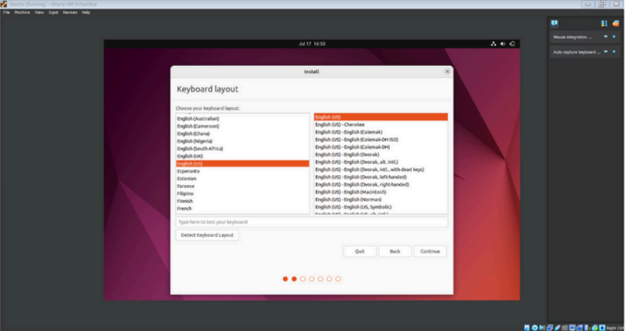

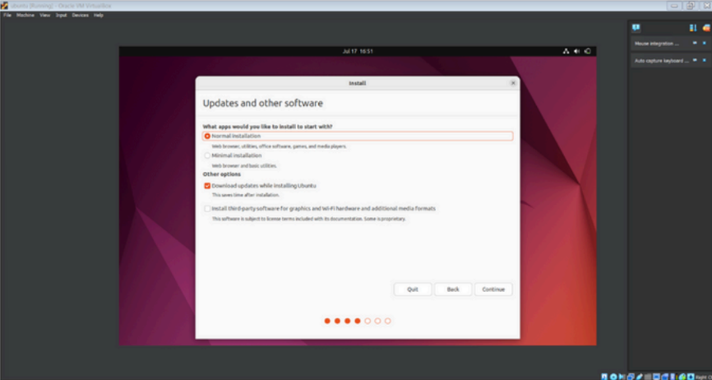**Step 8:** It will prompt us to choose updates and other software to install alongside Ubuntu. We choose the options and click on Continue.

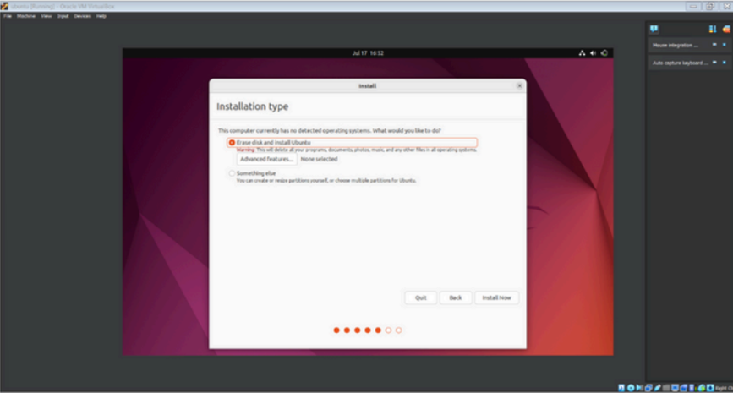**Step 9:** We will be asked to choose the Installation type. Once selected we can press Enter. We will be informed about the partitions being formatted. If it’s preferred, we press on Continue and proceed.

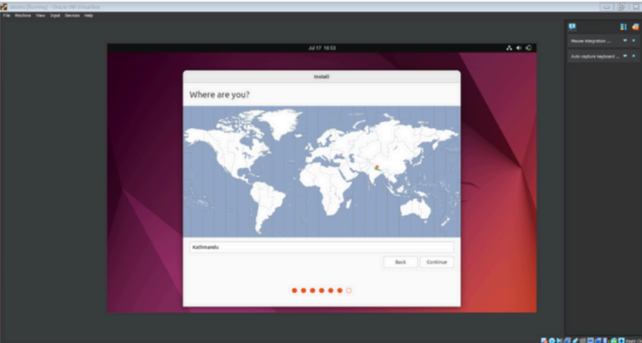**Step 10:** Select the location and press Continue.

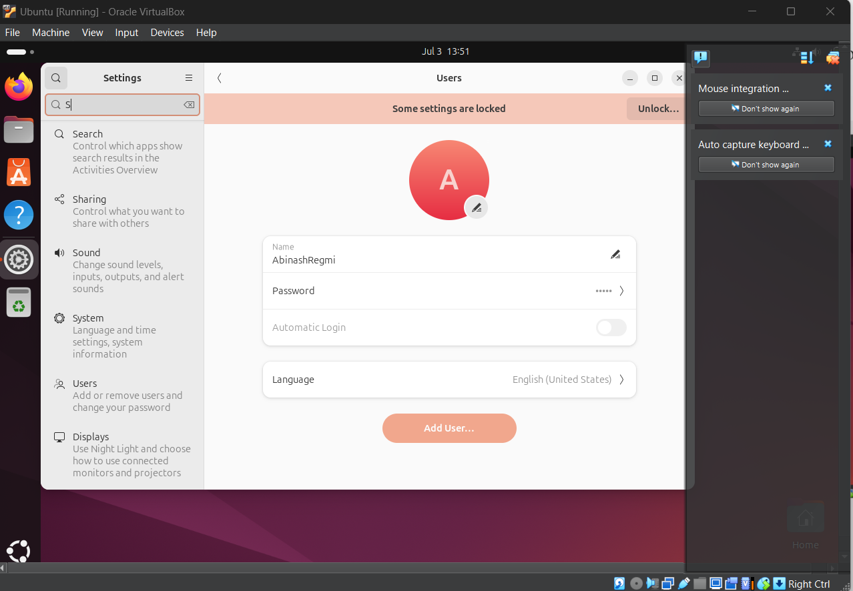**Step 11:** Setup the profile for the user that includes username and password, once finished press Enter

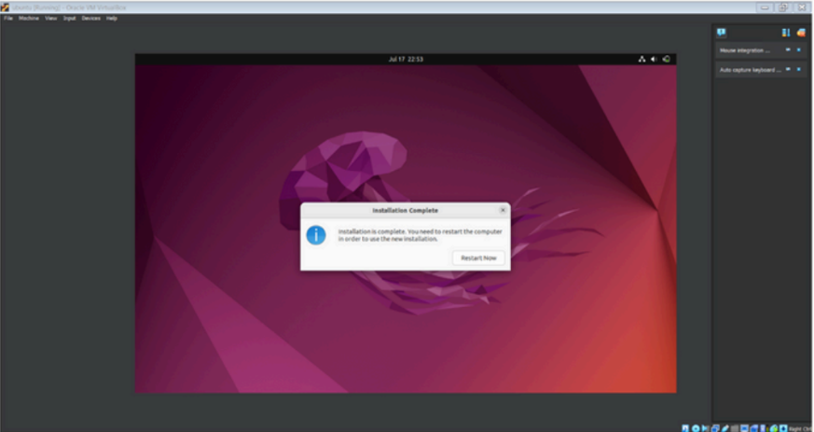**Step 12:** Upon the completion of the installation process, the window on the right will prompt, Restart Now.

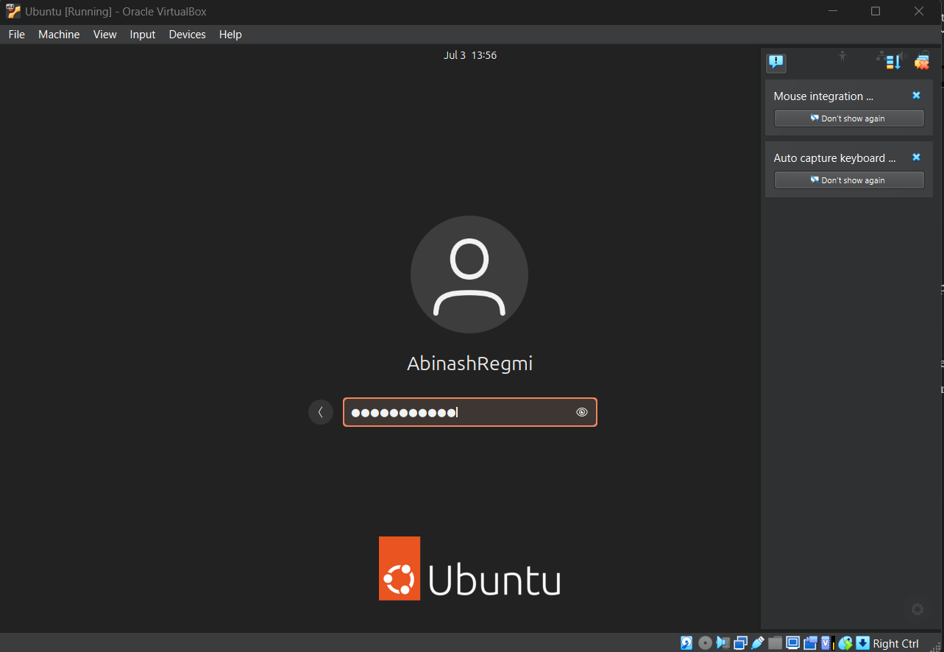**Step 13:** Now enter the Login details on the screen and press Enter to login into the system.

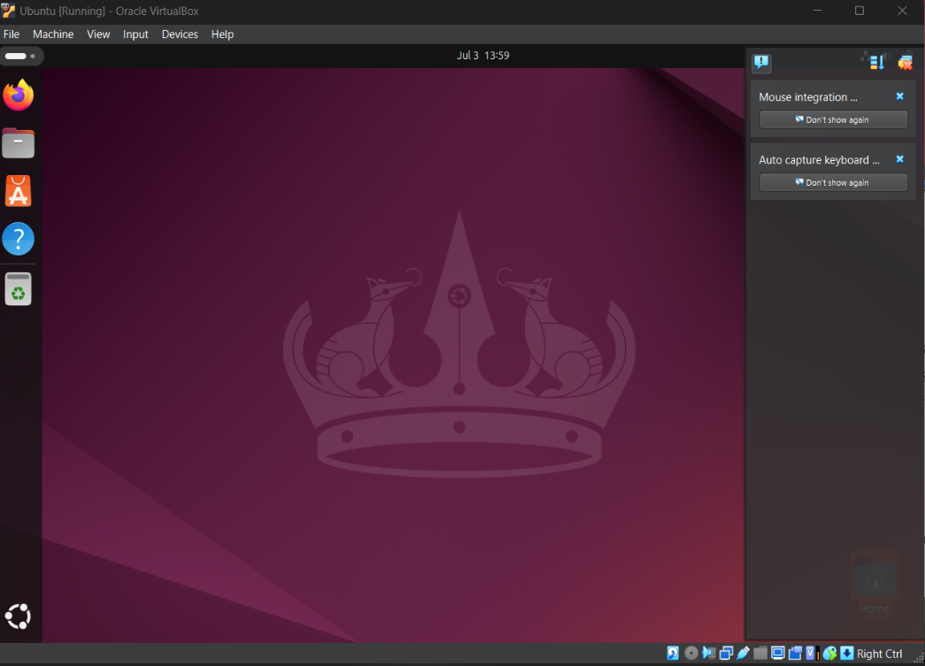**Step 14:** Now our system is ready and Ubuntu is installed completely.

**Networking Commands:**

1. **PING**

**Definition:** Ping (Packet Internet Groper) is a network utility used to test the reachability of a host and measure the round-trip time for messages sent from the originating host to a destination computer that are echoed back to the source.

**Syntax:** *ping [options] hostname or IP address*

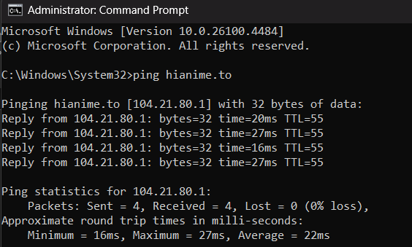**Use:** It is used to check the connectivity between my computer and the server to diagnose the network issue.

1. **IPCONFIG**

**Definition:** Ipconfig (Internet Protocol Configuration) is a command-line utility used to display and manage network configuration settings on Windows-based systems.

**Purpose:** To retrieve and display the current TCP/IP network configuration information on a Windows computer.

**Syntax:** Windows (ipconfig): *‘ipconfig[/all]’*

Unix/Linux(ifconfig): ‘*ifconfig[interface]*’

**Use:** It is used to check the IP address assigned to my computer and verify the network settings before troubleshooting the connection issue.

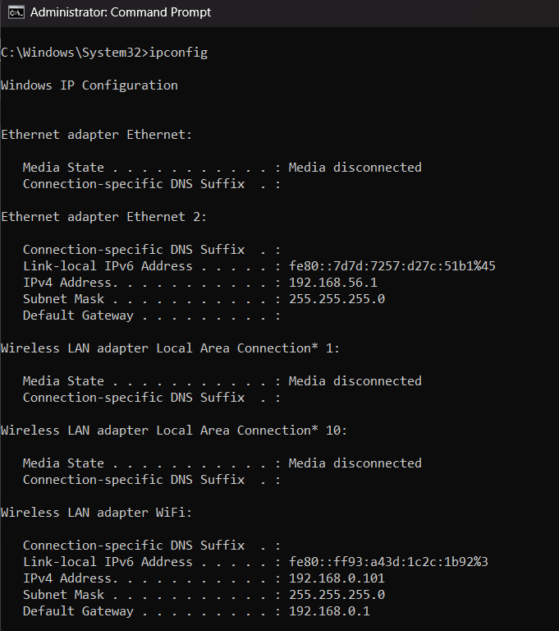

1. **GETMAC**

**Definition:** GETMAC is a Windows command-line utility used to retrieve the Media Access Control (MAC) address for network adapters installed on a computer. The MAC address uniquely identifies each network interface card (NIC) and is used for network communication.

**Purpose:** Retrieves the MAC address of a network adapter

**Syntax:** *getmac*

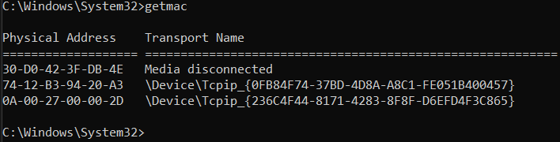**Use:** It is used to obtain the MAC addresses of all network adapters on my Windows machine, which helped in troubleshooting network connectivity issues and configuring specific network settings based on MAC address filtering.

1. **HOSTNAME**

**Definition:** A hostname is a label assigned to a device connected to a computer network that uniquely identifies it within that network.

**Purpose:** To provide a human-readable label that uniquely identifies a device on a computer network.

**Syntax:** *hostname*

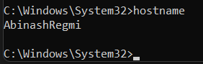**Use:** To display the system name

1. **TRACERT**

**Definition:** Tracert is a diagnostic utility that traces the path of a network packet from source to destination.

**Purpose:** Trace packet route to destination

**Syntax:** *tracert <hostname>*

**Use:** It’s a valuable tool for troubleshooting network issues like slow connections

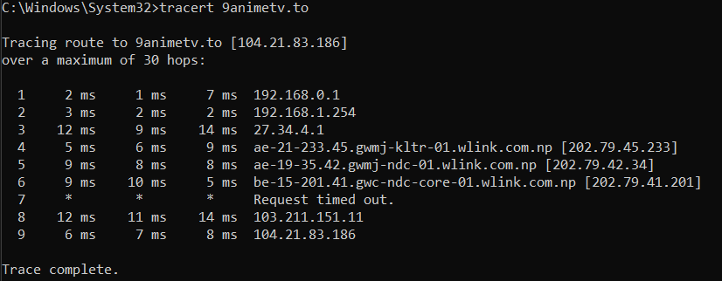

1. **NETSTAT**

**Definition:** Netstat (NETwork STATistics) is a command-line tool used to display network connections, routing tables, interface statistics, and more.

**Purpose:** To display network connections, routing tables, interface statistics, and multicast memberships on UNIX-like operating systems.

**Syntax:** *netstat*

**Use:** To diagnose network issues by examining active connections, routing tables, and interface statistics on my Unix-based system.

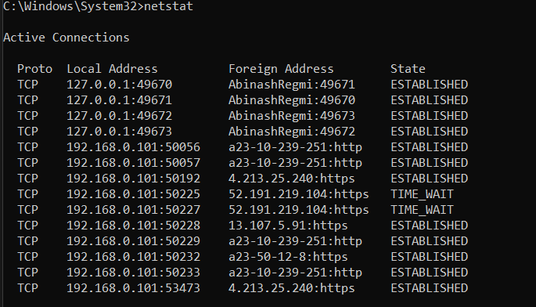

1. **NSLOOKUP**

**Definition:** NSLOOKUP (Name Server Lookup) is a command-line tool used for querying Domain Name System (DNS) servers to obtain DNS records and information about domain names, IP addresses, and related network services.

**Purpose:** View network connections and listening ports

**Syntax:** *nslookup <domain>*

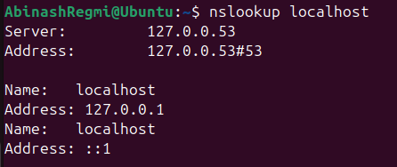**Use:** It is used for troubleshooting DNS issues, verifying DNS records, testing DNS configurations, and performing reverse DNS lookups

1. **ROUTE PRINT**

**Definition:** Route print refers to a command used to display the routing table of a device outlining the path that network traffic will take to reach various destinations.

**Purpose:** View routing table

**Syntax:** *route print*

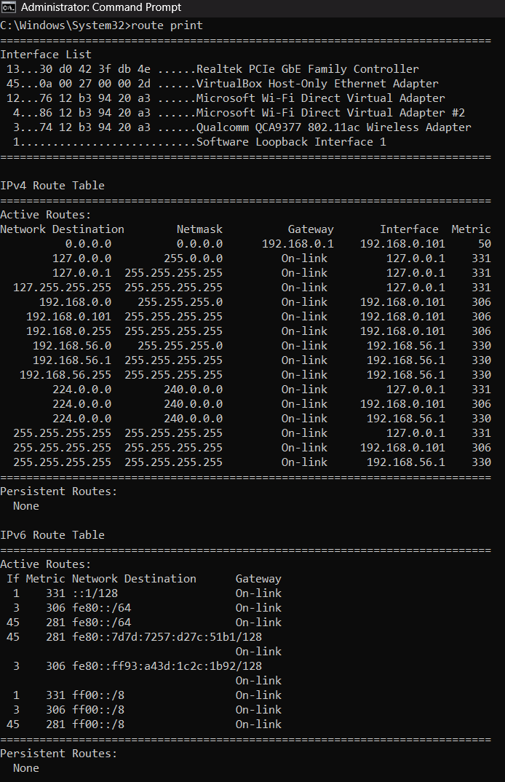**Use:** It shows the active network routes and how the system will direct traffic.

1. **NMAP**

**Definition:** Nmap (Network Mapper) is a powerful, free, and open-source tool used for network discovery and security auditing.

**Purpose:** Network scanner for hosts and ports

**Syntax:** *nmap <target>*

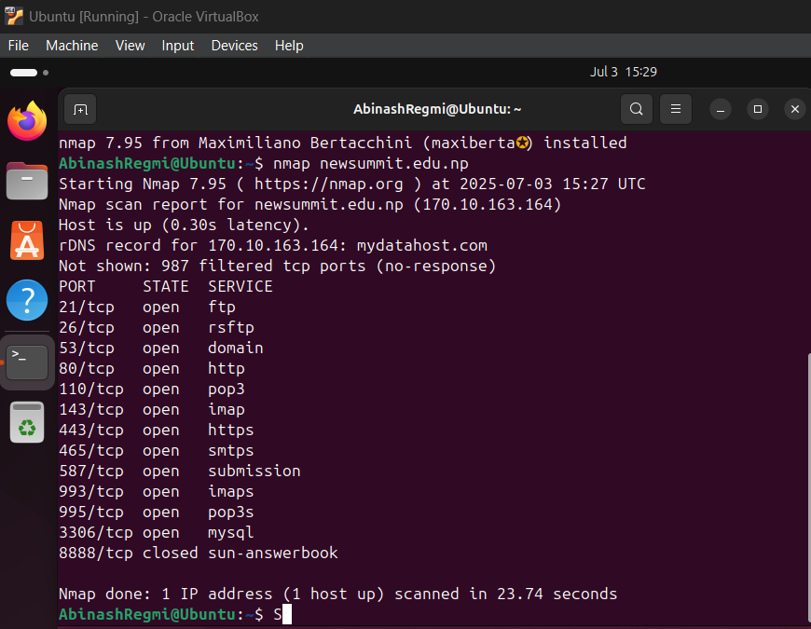**Use:** It helps admins and security professionals identify potential weaknesses.

1. **NETCAT**

**Definition:** Netcat is a versatile command-line tool used in computer networking to read and write data across network connections, supporting both TCP and UDP protocols

**Purpose:** Raw TCP/UDP connections and port scanning

**Syntax:** *nc -z -v <target> <port>*

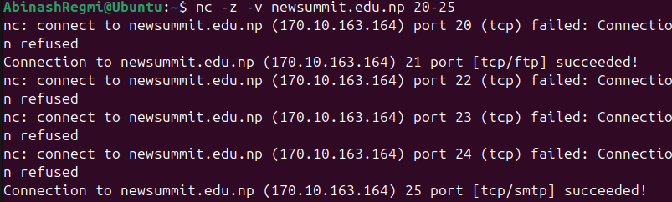**Use:** It enables actions like establishing connections, transferring data, and even basic port scanning.

1. **CURL**

**Definition:** Curl (Client URL) is a command line tool that developers use to transfer data to and from a server

**Purpose:** Transfer data to/from a server

**Syntax:** *curl <URL>*

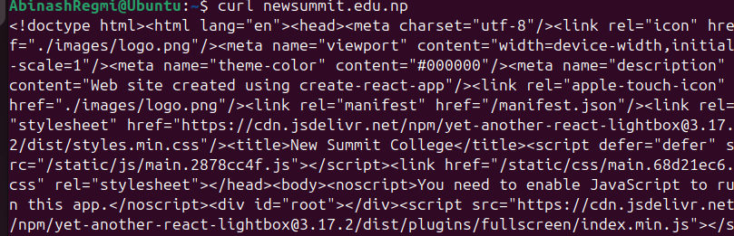**Use:** It is used to transfer data to and from Internet servers

1. **SYSTEMINFO**

**Definition:** Displays detailed configuration information about a computer and its operating system, including operating system configurations, etc.

**Purpose:** System hardware and OS info

**Syntax:** *systeminfo*

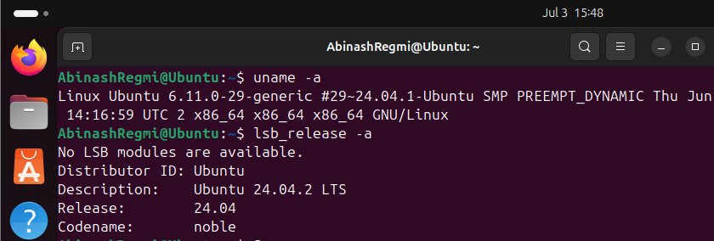**Use:** It helps us know hardware properties, product ID, security information, and so on.

Conclusion:

In this practical, the lab work involving the installation of VirtualBox or VMware and Ubuntu OS provided valuable insights into operating system fundamentals and virtualization concepts and technologies. Through practical exercises with basic networking commands such as PING, IPCONFIG, GETMAC, HOSTNAME, NSLOOKUP, TRACERT, NETSTAT, SYSTEMINFO, ROUTE PRINT, NMAP, NETCAT, and CURL, participants gained proficiency in network diagnostics, configuration, and system management. These activities contributed to a deeper understanding of essential tools for troubleshooting and optimizing network performances